Villalobos, Victor

Title: Trying to improve food choice and fight information asymmetry in the Latin-American food market.

June 07, 2012.

The airplane lands in Mexico City. I hope to get support to develop an app for nutritional orientation. As I travel along the streets, I witness again, the obesigenic environment I have been studying in the last 5 years. Food stalls pack the exits of the main subway stations. Food in the outdoor ads. Bigger-than-enough bellies on the passenger of public transportation. How did we make it to first place in childhood obesity and to first place in adult obesity? How come we were so fast?

Mexico has been among the top three countries in obesity since 2006. In seven years, we leapfrogged countries like the United States, the UK and Canada. When I was studying my masters at the National Institute of Public Health in 2002, it was obvious something was coming. We knew in 2000 that the incidence of diabetes had jumped from the early 90s. My professors did the analysis. They advised the minister of health about the issue. But no one knew for sure at that moment; we had to wait for the next national survey in 2006 to confirm what our eyes were witnessing in the streets: obesity had taken our country by storm.

One of the problems with the food market in Mexico suffers is that we have no limits on advertising or the location and intensity of the food industry. From the little boy that sells candies in the street to Femsa, the company that makes Coca-Cola in Mexico, there is no regulation on when enough is enough. So, the small entrepreneur and the large corporation have taken advantage of the popular saying “with food you never lose money.” Backed by “technological advances“ like PET bottles, portable digital devices, bar codes and trucks, soda companies have provided every other corner of low- to middle-income neighborhoods with convenience stores. Restaurant chains continue to open more and more places that sell food in “American sizes.” Traditional businesses have adopted the same philosophy. Now we have bigger portions everywhere.
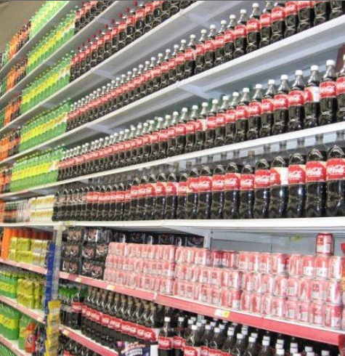
Columns of soda cans in a mega-store in Mexico City.

The second problem is lack of information from the consumer side. Although food engineers and administrative managers eat properly at home, in their jobs, they develop foods that might not pass the quality standard they follow at home. Fried bags of food, sold at a price per kilo three times more expensive than meat and 20 times more expensive than the in-season fruit, are made with low-cost ingredients of questionable nutritional quality. But the consumer does not know that.

In Mexico, it is rare to see people reading the ingredient list on packaged foods. It is even rare among nurses and health professionals in rural areas. They do not know what information is conveyed on the labels, and they do not know how to compare products based on them. Therefore, in the supermarket or convenience store, they cannot compare and choose the best food, even if they would like to. The result is that most people buy based on guesswork, if they are not completely guided by marketing campaigns, after price considerations are equal.

My first meting was at the national institute of public health, my former academic home. There, I found out there are several databases not released to the public. They do not know what use they could have. But I have an idea. One is a list of beverages, with nutritional information. The other is a list of supermarket products, with a nutritional score based on the type of food and its nutritional composition. These could be used to build a web-based service to provide nutritional information to the consumer. These could be the first block of products to run an educational site for the consumers. I know lots of people want to know this information. I worked in many place in Mexico, and people wanted this. I have the idea of developing an app that will develop consumer’s skills to compare and select products. Initially, it will give consumer nutritional ratings, but it will evolve, letting the consumer personalize their ratings.

How to make this idea a reality? I needed allies.

My next stop is the agency for consumers’ rights, PROFECO. A few calls and emails, and I have an appointment for next week with the coordinator of consumer education and organization. I arrive at 9:30. There, I am welcomed by the director, but three more people join us, all from the same area.

As I explain the project, they smile and nod in approbation. But I need more than that. I need their support— or at least a letter of support that could open other doors. One woman keeps typing in her Blackberry, although she also asked me a couple of questions. I study at Berkeley; I just got funding to come to Mexico; a program with a focus on food choice is being developed at Berkeley. I want to do it for Mexico.

“At what time do you need to leave” I am asked. “Well, I could stay longer, if necessary. Why?”

“What you need has to be approved by our boss, I am talking to the Vice Director, to see when he can meet you”….”he can meet you today at 1PM”.

Great! I go out for a coffee and prepare my speech. If I could get a letter from him, that could be excellent!

I Googled him. He also studied in the USA. Teacher in a private university, former aid at Los Pinos. He looks young. Maybe he would like this proposal using the internet….

When I go back, I am led to the private welcoming room of the director of PROFECO. “The Vice Director will be with you in a moment.” He was in a meeting all day long with the director and made time to go out and talk to me about my project.

“Hi, nice to meet you. How can I help you?” I proceed to explain the app that will deliver nutritional information to customers, at the supermarket, at restaurants, at convenience stores.

“Yes, yes, I do understand what you need. We are about to make public the database of our studies. Wait few weeks. But also, we are going to call for proposals, and yours could be funded. It would be launched in partnership with INDESOL.”

“Thanks but I will be pleased to get at least a support letter from you”.

“See, if I give you the letter, it would complicate the things when the call for proposals is launched. I suggest that you wait.” We talked for a little more. As I leave, he says “I hope this is just the beginning of our collaboration.”
--- *----

PROFECO is key to trigger collaboration with non-profit organizations and academic institutions. If I could get their support, that could catapult my project into a new arena. I might be able to get enough social support to launch the app. But in the mean time, it was time to visit some other social actors.

I went also to the National Association of Universities and higher education institutions, ANUIES. I also visited an institution of Baja California. Since Baja California and California have many collaboration treaties, I thought it was important to explore an opportunity to collaborate with them. Besides, I used to live on the border and know how much any type of social programs are needed there.

As my time in Mexico was finishing, I realized that the support for the app will also have to do with the fact that we will change government this year. If, at least, I could secure some support in the following months.

The links were established, but now it was time to make them grow and evolve, from Berkeley. Hopefully the app will see the light of the day next fall.

