Politics and Protest (and Lack Thereof) in Brazil

Last month, on October 26, 2014, Workers Parter (PT) incumbent Dilma Rousseff narrowly won reelection in Brazil’s presidential contest. Her center-right opponent, Aécio Neves (PSDB), earned 48 percent of the vote to Rousseff’s 52 percent. The three million vote margin made it the closest race since Brazil ratified its new constitution in 1988. As might be expected in one of the most stratified countries in the world, social class was one of the strongest predictors of candidate preference.

That the contest came down to the two establishment parties — and a significantly better showing for the self-described neoliberal party of PSDB — is puzzling. What, if any effect did the massive protests of June 2013 have on mainstream Brazilian politics? In the first round of voting, the left-socialist candidate, Luciana Genro, earned nearly twice the amount of votes as had her predecessor in 2010. But the far right gained almost as much ground, too. Below, I reflect on my summer of research on the June 2014 protests (and their relationship to 2013) in an attempt to understand the composition, grievances, and political import of the demonstrations in Brazil.

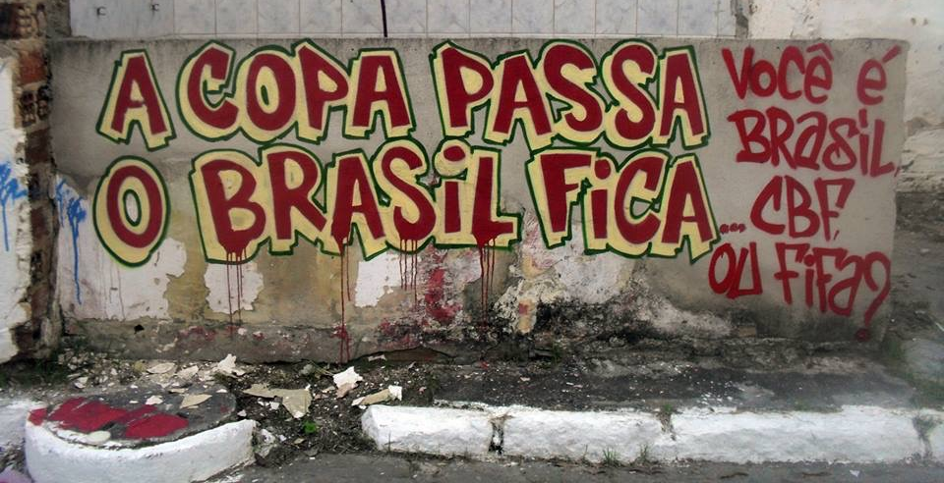

Street graffiti in Rio de Janeiro that reads: “The Cup ends / Brazil remains. [Do you support] Brazil, the Brazilian Confederation of Football, or FIFA?”

“VOTO NULO”

This summer, I spent 10 weeks in Rio de Janeiro conducting fieldwork on the World Cup protests (and lack thereof). I interviewed Brazilians from a range of class, gender, age, and racial backgrounds, sampling both protest participants and those who stayed on the sidelines. I also visited one of the Homeless Workers Movement’s (MTST) encampments in São Paulo and interviewed government officials in the capital city of Brasília.

According to many observers, the beauty of Brazil’s so-called June Days — the country’s largest uprising since the fall of the dictatorship 25 years prior — were that they were horizontal, leaderless, and for the most part, avowedly apolitical. The estimated one million people who filled the streets in over 350 cities brought contradictory demands. One common thread, however, seemed to be the protestors’ disillusionment with all forms of organized politics, from parties to unions, from NGOs to traditional social movements like the renowned Landless Movement (MST). (The protestors’ pretense of political neutrality stands in marked contrast to, for example, Spain’s indignados, who formed the political party Podemos, which captured 1.2 million votes and five congressional seats in May 2014.)

An overwhelming number of my interview respondents indicated that they intended to annul their vote this October. “Voto nulo” or “voto em branco” — I’ll abstain from voting — many of them said. To be sure, the fact that I spoke with them in July could mean that they simply had not yet given thought to it yet. At the same time, as illustrated in the picture and screen shot below, there is a growing impulse among activists — those who the social science literature would expect to be most politicized — to “boycott” the 2014 election altogether. Indeed, the proportion of annulled, blank, and abstention votes in Rio reached nearly a third of the electorate—surpassing other regions and previous elections.
The top photo is a screen shot from Anonymous Rio’s Facebook page. It reads: “There won’t be a vote. Operation boycott the elections.” The second photo is taken from a June 2014 street protest in Copacabana. The large red banner implores Brazilians to “não votar” — don’t vote.

On almost every indicator, the 2014 demonstrations paled in comparison to those of 2013. I attended seven of the protests in Rio, which were scheduled to coincide with the events of the Cup. None exceeded a headcount of more than 2,000. Most were in the low hundreds — a sharp decline from the 300,000 who took to the streets of Rio a year earlier. The reasons for the disappearance of the masses are no doubt multi-causal: Brazilians’ love for the game of futebol, police intimidation and repression, and the media’s spectacular ability to manipulate the narrative of the unrest in the streets. All of these factors, however, attribute the power to shape whether and how social change occurs to structural forces that are completely out of the hands of the protestors. Moreover, all canonical social movements — from the civil rights movement to anti-apartheid struggles — faced similarly fierce opposition from the state, the private sector, and the media.

So what accounts for the fact that the protestors failed to evolve into a sustained movement? The evidence suggests that one potent explanatory factor is that the demonstrations were simply not organized. They lacked leadership — not in the sense that they did not have a charismatic figure like Martin Luther King or Nelson Mandela — but rather in the sense that the outpouring in the streets relied on social media mobilizations convoked in cyberspace rather than on the work of skilled organizers who took on the specific task of building a movement.

Below, I recount the events of July 13, 2014 to provide one illustration of how these factors converged to stifle — at least for the time being — the unrest in Brazil’s streets.

WHAT HAPPENED ON JULY 13, 2014 (ASIDE FROM THE WORLD CUP FINAL)?

With help from a team of Brazilian undergrads, I probabilistically sampled and interviewed 45 of the roughly 300 demonstrators who attended the World Cup final protest on July 13, 2014. The demonstrators gathered at Praça Saens Pena in the neighborhood of Tijuca, approximately a mile away from Maracanã, where Argentina faced off with Germany for the final match of the tournament.

The protest began peacefully. At 2:00 p.m., activists gathered in the central plaza and began to unfurl their banners. Although the group was more politically homogenous than the June 2013 protestors — where I had seen antithetical posters side-by-side (one demanded free public transportation and the next insisted on an end to all welfare programs) — the 2014 demands remained diverse. A 40-person-strong contingent protested the Israeli invasion of Gaza, using child-sized coffins as symbolic props. A small group from the Free Fare Movement (MPL), which is credited with initiating the 2013 mass protests in São Paulo, was present. Others, as in the banner below, continued to protest the “World Cup of Blood” and the many injustices committed in the name of the soccer mega-event.

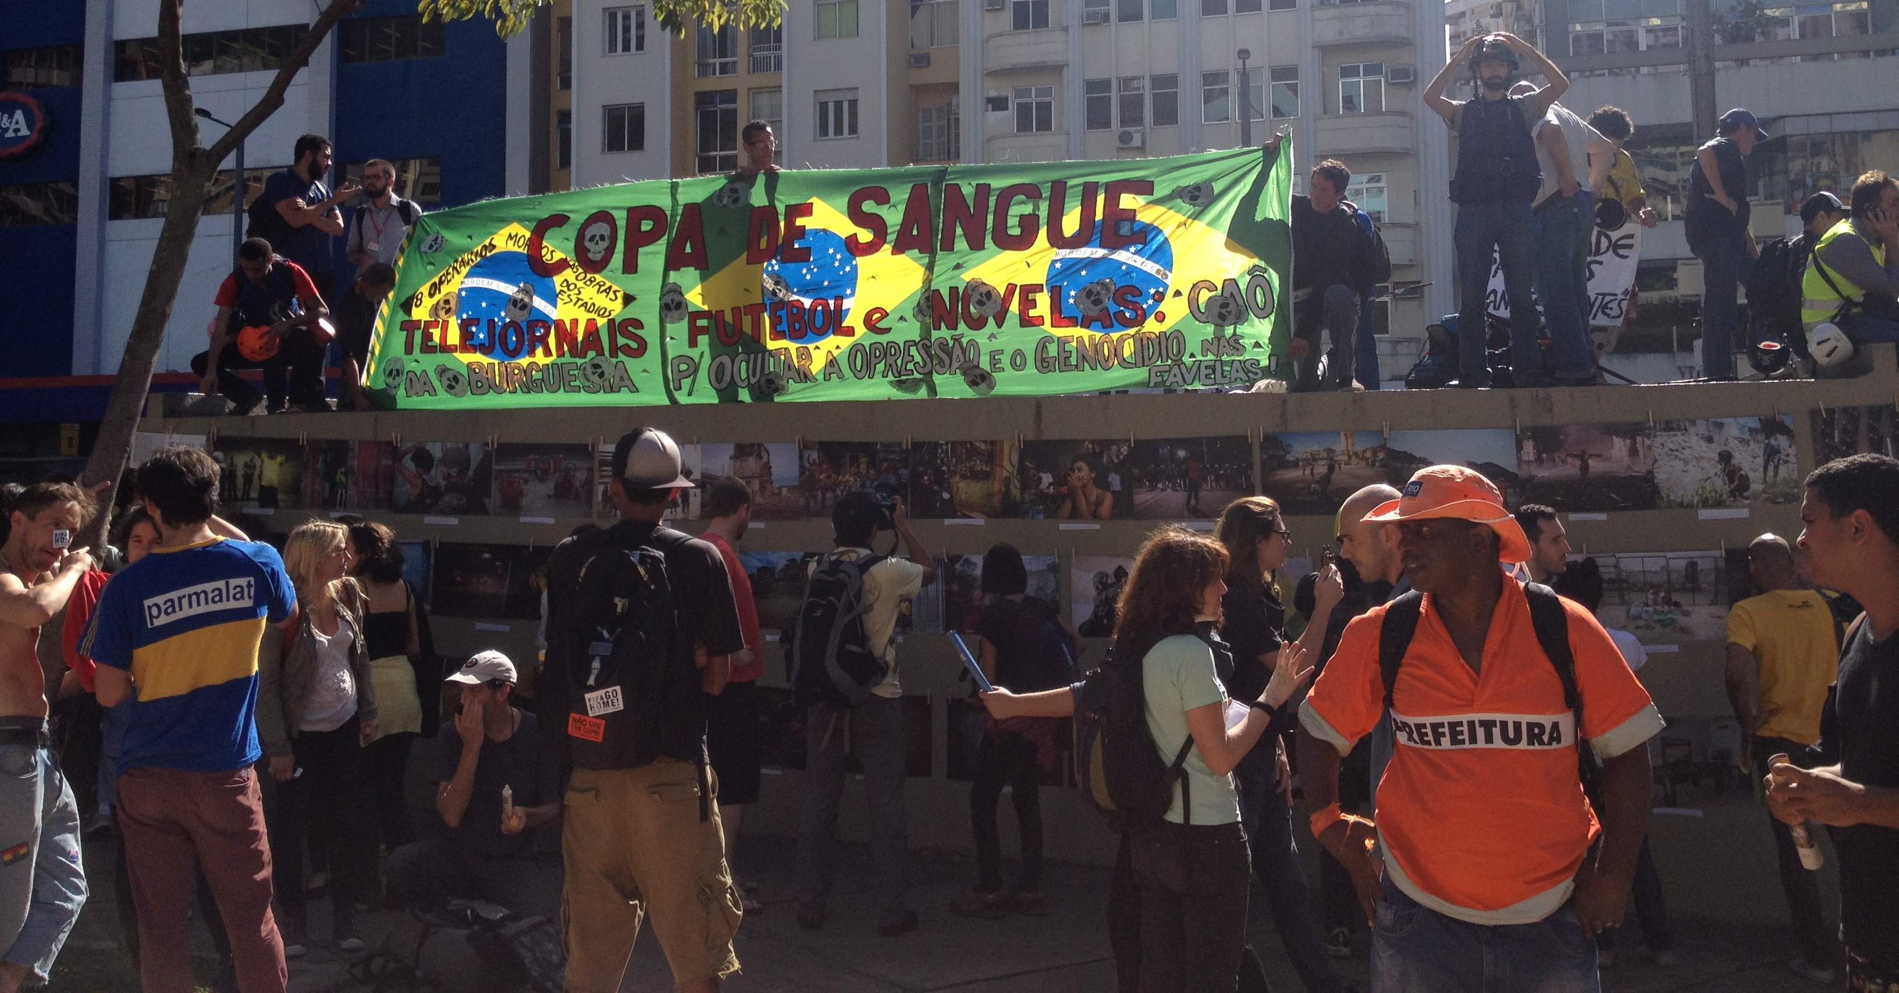
Image taken at the protest that coincided with the World Cup final match. The banner reads, “World Cup of blood: TV news, soccer, and soap operas: bourgeois lies to hide the oppression and genocide in the favelas.”

But the loudest voices and chants demanded the release of the “political prisoners.” On the eve of the protest and under the auspices of so-called “Operation Firewall 2,” police went to the homes of 28 activists and arrested them on the spot. Civil Police Chief Fernando Veloso alleged that those targeted were “clearly mobilizing to organize violent acts” during the final match, a continuation of the black bloc repertoire of tactics that included the occasional Molotov cocktail and an attempted occupation of a government building. Most of the activists were released 12 days later under habeas corpus laws.

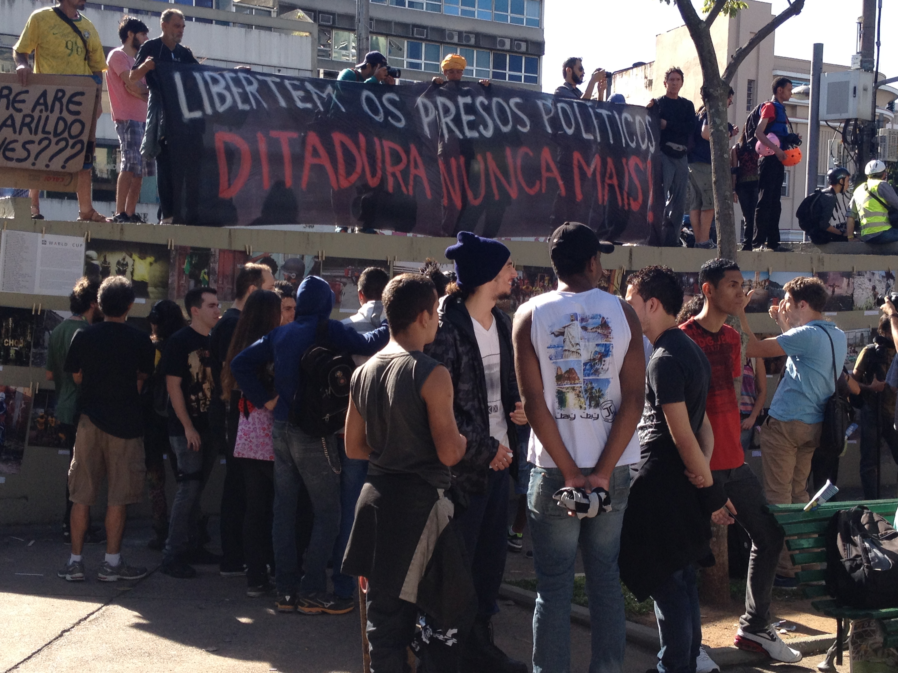
A second banner from the World Cup final match protest. It reads, “Liberate the political prisoners. Dictatorship — never again!”

When the soccer match kicked off at 4:00 p.m., the demonstrators began to move, amoeba-like, into the street. The more than 200 military police officers, whose all-black armored uniforms gave rise to the derisive nickname “robo-cops,” blocked their path. Unable to advance on the stadium, the protestors spontaneously marched in the opposite direction, away from Maracanã. The crowd thinned.

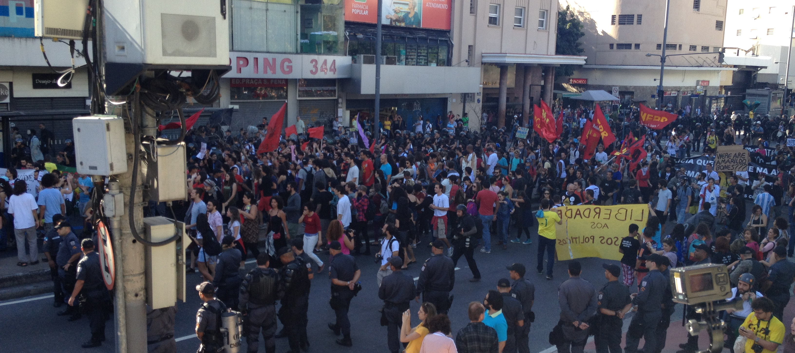
Unable to breach the police barricade en route to the stadium, the protestors proceeded in the opposite direction — at least momentarily.

Ten minutes later, roughly 100 protestors returned to the plaza, running at full speed. They made a futile attempt to breach the police barricade a second time, in an attempt to advance on the stadium. The military police reacted swiftly and in unison, throwing tear gas bombs indiscriminately into the crowd and physically attacking protestors. We ran.

The most obvious escape route was into an underground metro station. The staircase was narrow and police began to close the entrance gates, preventing protestors from fleeing the clouds of tear gas that engulfed the crowd. I overheard a 20-something woman yell to her group of friends, “Are we all together? We can’t leave anyone behind!” As much of the crowd descended into the metro station, the military police followed, brandishing — and sometimes using — their clubs to attack any protestors who crossed their paths. They catapulted more tear gas bombs into the airless metro station, compounding the stinging and suffocating effect of the noxious chemicals. We were fortunate to get on the last train out of Tijuca. Those who weren’t as lucky were surrounded in a militarized circle and held captive in the plaza until the match ended that evening.

Reflecting on the effect of police repression on protests, activist-scholar Jo Freeman writes: “Don’t underestimate repression as a way to kill movements. It doesn’t always work, but when it does, it’s very effective.” The harsh and disproportionate response of the state in the case of the 2014 World Cup protests cannot be dismissed. Yet even before the robo-cops were deployed in full force, the protesting masses had long since dissipated in the months prior to the Cup. Did police repression “kill the movement” in Brazil? Or are there other important explanatory factors to be analyzed?

PROTEST OR SOCIAL MOVEMENT?

“Masses alone do not form movements, however discontented they may be.”

A cursory analysis of my data suggests that what happened this summer in Brazil — or more accurately, what failed to happen — substantiates a quiet strain in the social movement literature that argues that organization is the sine qua non of successful social movements. Again, Jo Freeman: “It should be obvious that movements don’t happen by themselves. There must be grievances and organization.”

The leaderlessness of the throngs of World Cup demonstrators was thrown into sharp relief when I visited an MTST encampment in São Paulo. It was an intolerably hot Sunday, and organizers had scheduled a meeting in Vila Praia, a favela that lies just outside the wealthy neighborhood of Morumbi. Approximately 400 homeless workers, many of whom had participated in the occupation of a nearby construction site as a tactic to demand that the government build more and higher quality housing, were present.

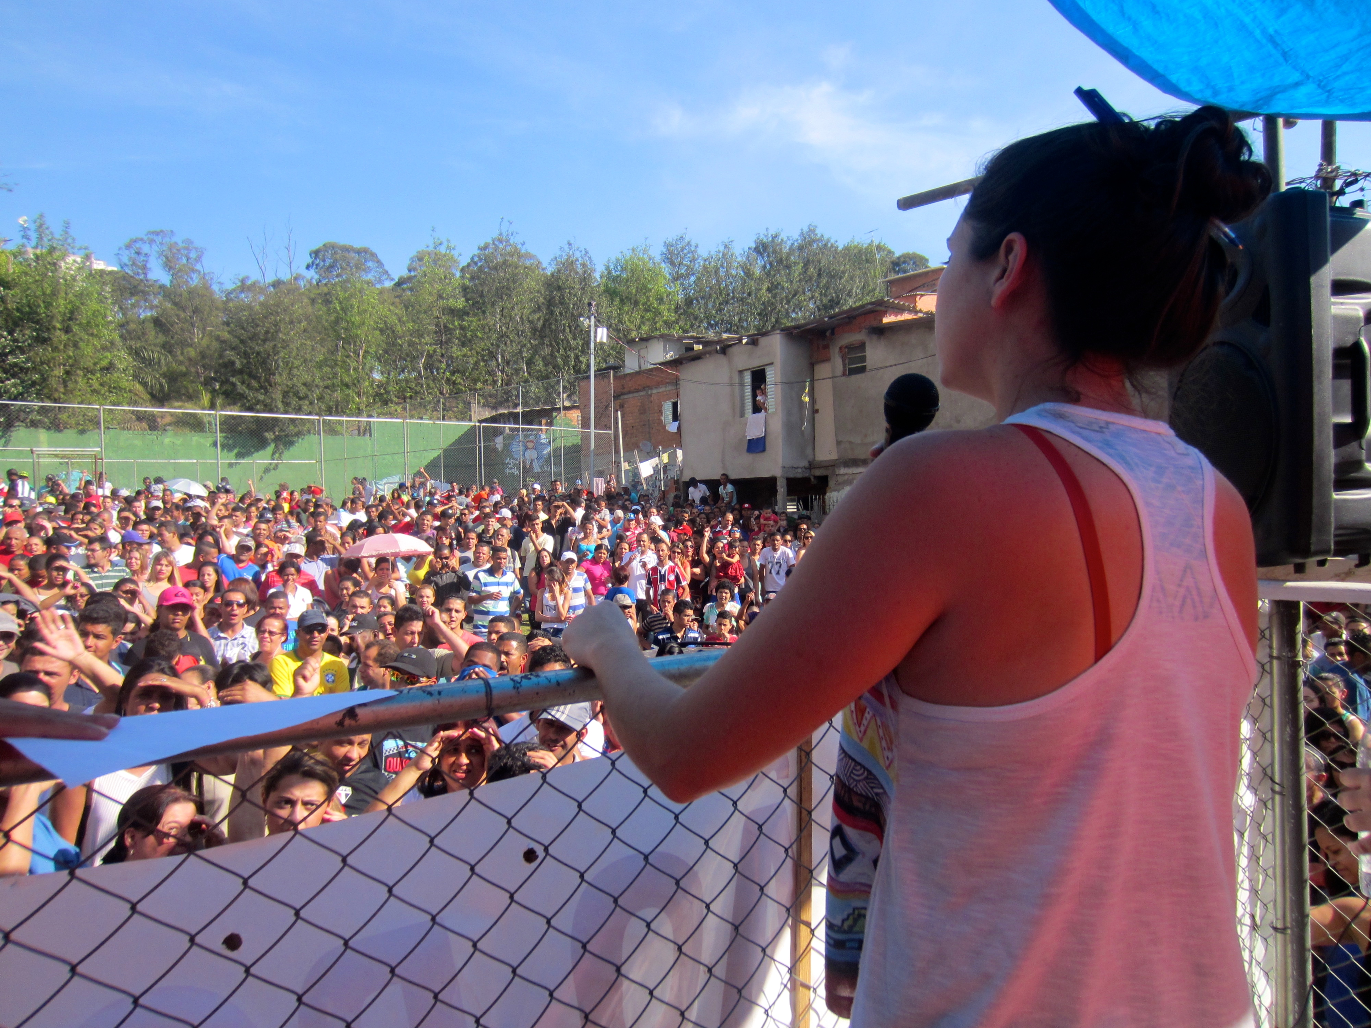
On a scorching hot day in São Paulo, nearly 400 members of the Homeless Workers Movement (MTST) attended a planning meeting, led by Ana (pictured) and five other MTST militants.

The local branch of MTST leadership, a half-dozen internally elected representatives, had called the meeting to explain to the homeless workers their rights with respect to the agreement the Movement had brokered with the city housing authority. The families listened attentively and asked trenchant questions about the step-by-step instructions on how and when to register for the program, which would allow them to qualify for low-income housing units. It was a remarkably well-executed meeting that built the power of the MTST constituency even as it made demands on the state. As Guilherme Boulos, the titular leader of the Movement explained, “The difference is that we can negotiate [with the state] on our knees, or if we engage in dialogue, standing up. If you go inside the institution, you dialogue within the logic of favors and concessions. If you dialogue from outside, marching and struggling, you engage in dialogue as equals.” It became clear to me that it was through organization, however imperfect, that the dispossessed workers began to wield more power vis-à-vis the state. MTST was unquestionably more effective in achieving their aims than the internet-savvy, well-educated, and better off protestors I had seen so many times on the streets of Rio over the past year.

Many questions remain. As I sift through my data — and return to Brazil for follow-up research in the years to come — I hope to gain more analytical clarity on the following three sets of questions:

- MACRO: Where does the case of Brazil fit into the global wave of protests that began in 2009? Do the demonstrations reflect short-term, apolitical mobilizations, or are the seeds of a broad-based, organized movement being sown?
- MESO: What is the relationship between the content of protestors’ grievances and the way in which they organize themselves (or don’t)? Which movements predated and outlasted the modish demonstrations of June 2013? Why? What is the role of the organizer or leader in this new species of urban protest?
- MICRO: To what extent do protestors need to believe in the efficacy of protest before they are moved to participate? How do demonstrators with divergent demands arrive at a shared purpose such that they are compelled to act together?

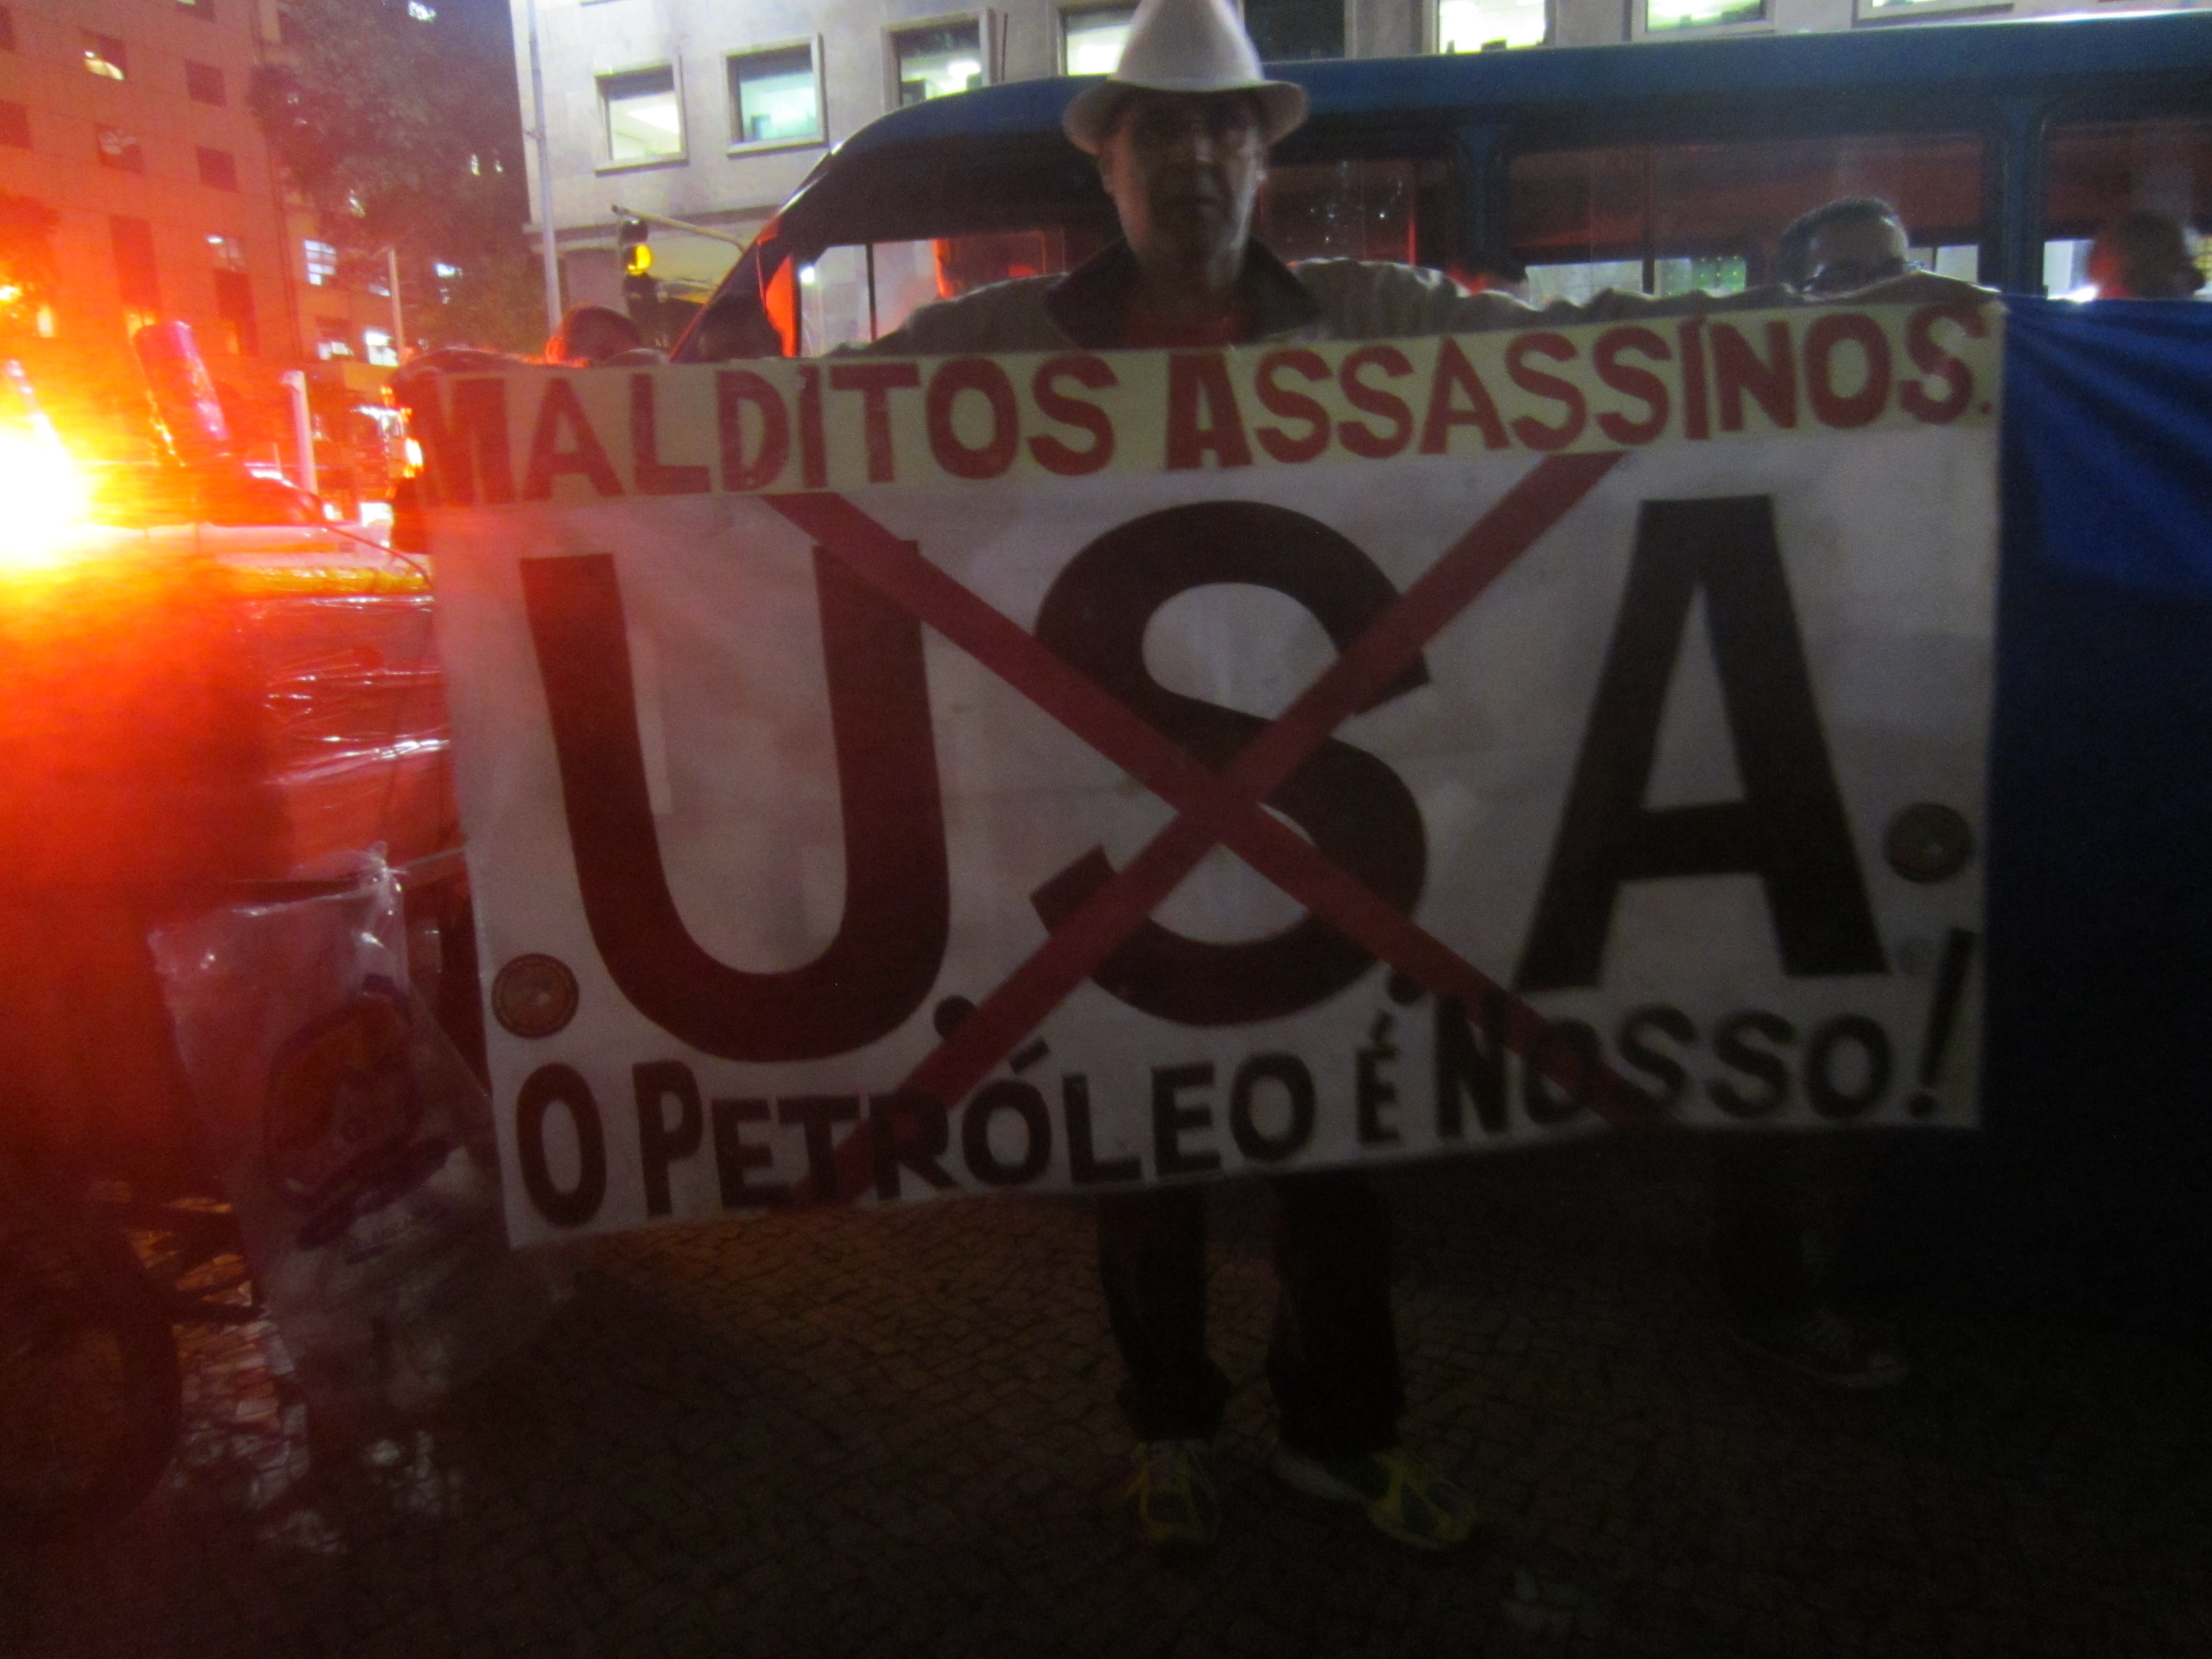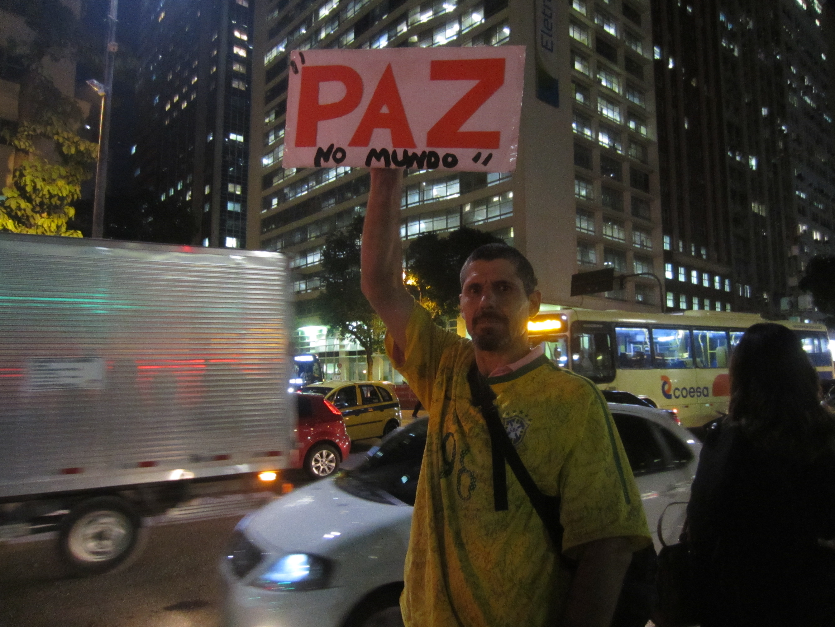

An example of the contradictory demands present at a July 30, 2014 protest in Rio. The purported aim of the demonstration was to protest imprisonment of the 28 activists arrested on July 12. The two lone wolf demonstrators above had divergent aims — from one another and from the stated theme of the demonstration. (The sign on the left reads, “USA — damned murders — the oil is ours!” On the right, “Peace on earth.”)

A FINAL CONSIDERATION: SOCIAL CLASS AS A KEY VARIABLE

The recent movements make dignity and democracy the goal, more than combatting poverty. They are democratic and moral protests, just like the majority of the other recent [global uprisings].
—Manuel Castells in an interview with O Globo.

Interviews I conducted with elite, middle-class, and impoverished Brazilians who did not attend the protests suggest that a person’s location in the social structure predicts his or her view of the mass urban demonstrations. I interviewed an equal number of people from each of these categories and found that upper-middle class respondents had a much more favorable view of June 2013 protests. Residents of Rocinha and Complexo do Alemão, the two favelas from which I recruited participants, were more wary. If the protests were indeed “democratic and moral protests” and not about righting the wrongs of poverty, as Manuel Castells contends in the above quotation, it makes sense that the wealthier would have a more favorable view of them and that the poor would be more skeptical. This pattern suggests that class is a key variable for understanding not only the nature of the protests but also whose interests they represented.

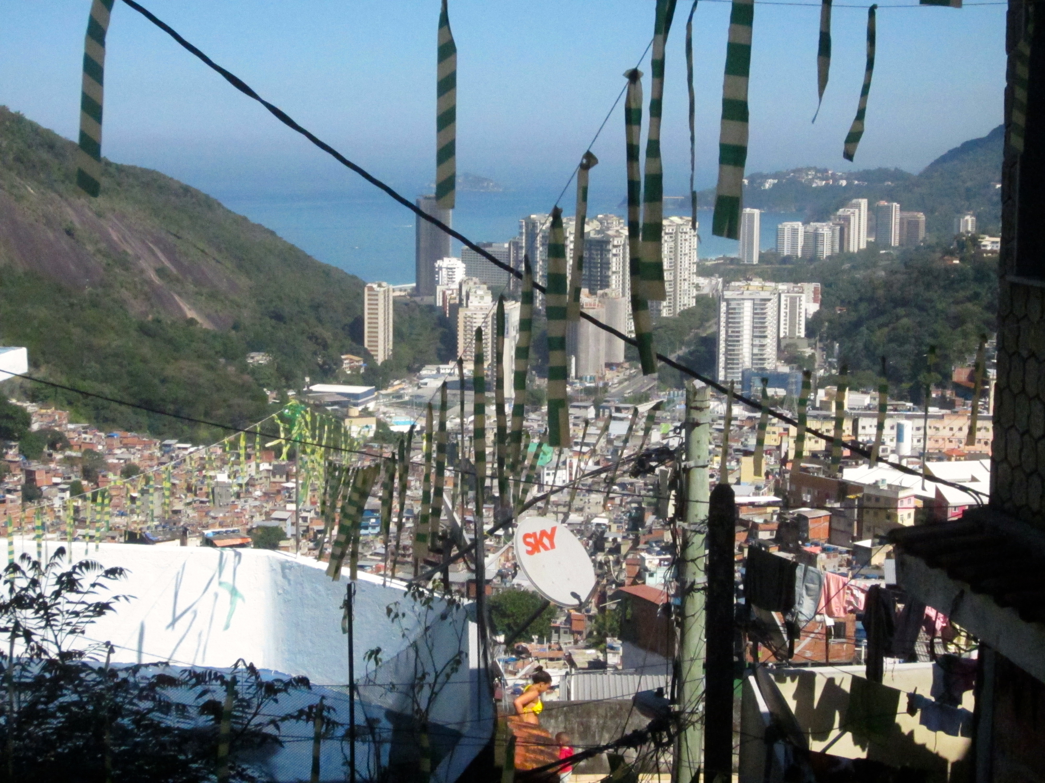
View from approximately halfway up the hillside of the favela Rocinha. In the foreground, leftover decorations from the Cup, a cable TV dish, and a few of the roughly 100,000 makeshift houses that make up Rocinha. In the background, the luxury beachfront condominiums of São Conrado.

BRAZIL IN 2014 AND BEYOND

As Luiz Felipe Miguel writes, Brazil continues to be beset by conflicts that are the product of “a social world that is both plural and unequal.” Indeed, no two words seem to better describe Brazil at its current inflection point. They bear repeating: plural and unequal. The fate of Brazil’s puzzling cycle of protest and passivity seems to depend to a large extent on the presence or absence of organizers, whether the demonstrations build power or are instead ephemeral performances, and how grassroots leaders address this core tension of plurality and inequality.

Freeman, Jo. 1999. "On the Origins of Social Movements." In Waves of Protest: Social Movements since the Sixties. Lanham, MD: Rowman and Littlefield. 7-24.
Ibid. 2014. “Grievance and Organization” in Mobilizing Ideas.
Interview with Guilherme Boulos. “MTST, the new protagonist,” in Carta Capital. Available: http://www.cartacapital.com.br/revista/802/os-novos-protagonistas-631.html
These qualitative findings are supported by available quantitative evidence, too. The public opinion polling firm Datafolha found that the June 2013 protesters earned on average more than two times the minimum wage and were relatively well-educated and media-savvy. In São Paulo, over 77 percent of the demonstrators had attained some education beyond high school, and in Rio de Janeiro fully 86 percent had attained either their high school or university diploma. A staggering 84 percent of survey respondents did not claim affinity for any political party, all attributes that do not conform to the profile of Brazil’s sub-proletariat masses. In subsequent surveys, public support for the protests declined from 89 percent in June 2013 to 66 percent in October 2013. Upper-class respondents were much more likely to continue to support the protests (80 percent) as compared those with the least schooling (47 percent) and those from lower income-brackets (42 percent).

